Submitted To:

Engineer Sheharyar Khan

Name: Iqra Fatima

Reg. Number: 23-CP-62

Semester: 3rd

Department: CPED

Data Structures and Algorithms

(DSA)  
Lab Report 2

Marks Obtained: 8

Total Marks: 8

**Marks Distribution:**

Total Lab Report Marks: 04 Total Lab Activity Marks: 04

Table of Contents

1

Examples: 4

Task 1: Python Arrays 4

Code: 4

Output: 4

Task 2: Advanced Python Arrays 4

Code: 4

Output: 5

Task 3: Solving Real-Life Problems with Arrays 5

Code: 5

Output: 5

Task 4: Python Classes and Objects 5

Code: 5

Output: 5

Task 5: Encapsulation Using Private Members 6

Code: 6

Output: 6

Task 6: Python Inheritance 6

Code: 6

Output: 7

Task 7: Polymorphism (Overloading and Overriding) 7

Code a: 7

Output: 7

Code b: 7

Output: 8

Task 8: Abstraction Using Abstract Classes 8

Code: 8

Output: 9

Task 9: Python Modules 9

Code: 9

Output: 9

Task 10: Python File handling 9

Code: 9

Output: 9

Task 11: Python JSON 10

Code: 10

Output: 10

Task 12: Python Regular Expressions 10

Code: 10

Output: 10

PROBLEMS 10

Beginner Problems 10

Question 1: Array Rotation 10

Question 2: Encapsulation with Getters and Setters 11

Question 3: Date Difference 13

Question 4: Basic JSON Handling 13

Question 5: Using Python Math Library 14

Intermediate Problems 15

Question 6: File Handling: Find Longest Word 15

Question 7: Inheritance: Employee and Manager Classes 16

Question 8: Regex Validation for Email 17

Question 9: Python String Formatting 18

Question 10: User Input and PIP Library Usage 19

Advanced Problems 20

Question 11: Polymorphism: Shapes Area Calculation 20

Question 12: Abstract Class for Payment Processing 21

Question 13: JSON Data Analysis 22

Question 14: Regex Search in Log File 23

Question 15: File Handling: Merge and Sort Files 24

# Examples:

## Task 1: Python Arrays

### Code:

### Output:

## Task 2: Advanced Python Arrays

### Code:

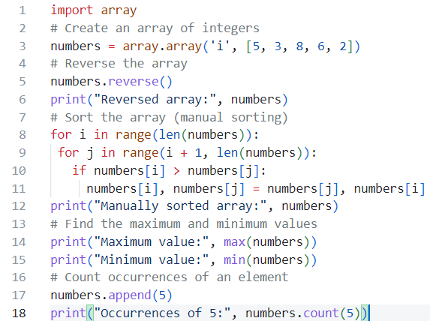

### Output:

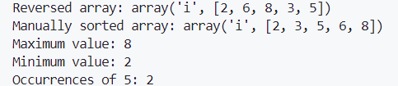

## Task 3: Solving Real-Life Problems with Arrays

### Code:

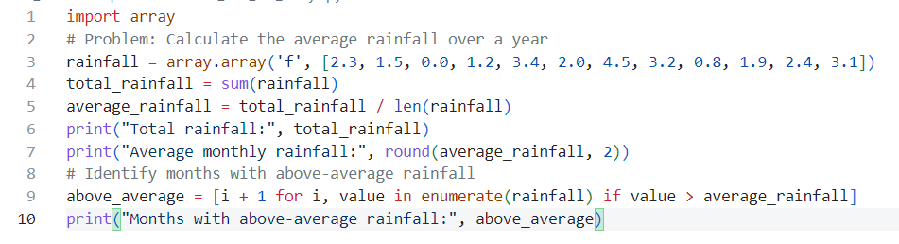

### Output:

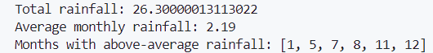

## Task 4: Python Classes and Objects

### Code:

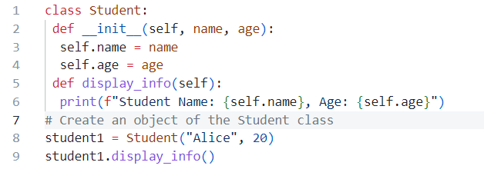

### Output:



## Task 5: Encapsulation Using Private Members

### Code:

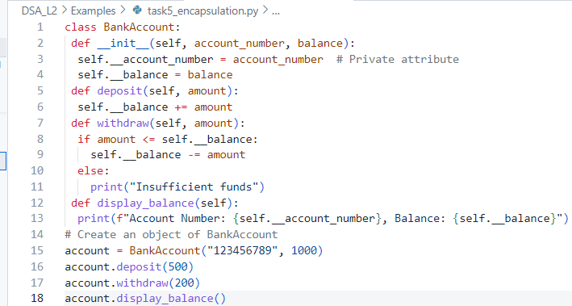

### Output:



## Task 6: Python Inheritance

### Code:

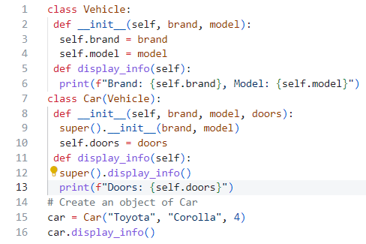

### Output:



## Task 7: Polymorphism (Overloading and Overriding)

1. Overloading

### Code a:

### Output:



1. Overriding

### Code b:

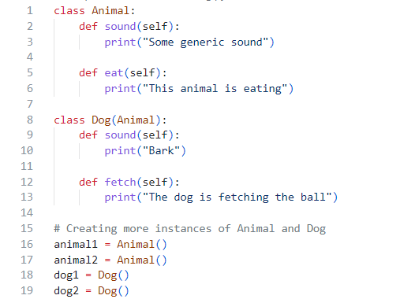

### Output:

## Task 8: Abstraction Using Abstract Classes

### Code:

### Output:



## Task 9: Python Modules

### Code:

### Output:



## Task 10: Python File handling

### Code:

### Output:



## Task 11: Python JSON

### Code:

### Output:



## Task 12: Python Regular Expressions

### Code:

### Output:



# PROBLEMS

## Beginner Problems

### Question 1: Array Rotation

Write a Python program to rotate an array by a given number of

steps.

o Input: [1, 2, 3, 4, 5], Steps: 2

o Output: [4, 5, 1, 2, 3]

#### Code:

n=int(input("Enter the number of elements in the array: "))

arr=[]

for i in range(n):

    arr.append(int(input("Enter the element: ")))

steps=int(input("Enter the number of steps to rotate the array: "))

print("Original array:",arr)

for i in range(steps):

    arr.insert(0,arr.pop())

print("Rotated array:",arr)

#### Output:

### Question 2: Encapsulation with Getters and Setters

Create a class BankAccount with private attributes account_number and balance. Use getters and setters to update and retrieve

these values.

o Input: account_number=12345, balance=10000

o Output: Account Number: 12345, Balance: 10000

#### Code:

class BankAccount:

    def __init__(self, account_number, balance):

        # Private attributes

        self.__account_number = account_number

        self.__balance = balance

    # Getter for account_number

    def get_account_number(self):

        return self.__account_number

    # Setter for account_number

    def set_account_number(self, account_number):

        self.__account_number = account_number

    # Getter for balance

    def get_balance(self):

        return self.__balance

    # Setter for balance

    def set_balance(self, balance):

        if balance >= 0:  # Ensure balance is not negative

            self.__balance = balance

        else:

            print("Balance cannot be negative!")

    # Display account details

    def display_details(self):

        print(f"Account Number: {self.__account_number}")

        print(f"Balance: {self.__balance}")

# Main block for testing

if __name__ == "__main__":

    # Take input from the user

    account_number = int(input("Enter account number: "))

    balance = float(input("Enter initial balance: "))

    # Create BankAccount object

    account = BankAccount(account_number, balance)

    # Display initial details

    print("\nInitial Account Details:")

    account.display_details()

**# Update values using user input**

    new_account_number = int(input("\nEnter new account number: "))

    account.set_account_number(new_account_number)

    new_balance = float(input("Enter new balance: "))

    account.set_balance(new_balance)

**# Display updated details**

    print("\nUpdated Account Details:")

    account.display_details()

#### Output:

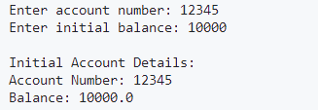

### Question 3: Date Difference

Write a program to calculate the number of days between two given dates.

o Input: Date 1: 2025-01-01, Date 2: 2025-01-15

o Output: Difference: 14 days

#### Code:

from datetime import datetime

def date_difference(date1_str, date2_str):

    # Convert the string dates to datetime objects

    date_format = "%Y-%m-%d"

    date1 = datetime.strptime(date1_str, date_format)

    date2 = datetime.strptime(date2_str, date_format)

    # Calculate the difference in days

    difference = (date2 - date1).days

    return difference

# Input dates

date1 = "2025-01-01"

date2 = "2025-01-15"

# Calculate and print the difference

days_difference = date_difference(date1, date2)

print("Difference:", days_difference, "days")

#### Output:



### Question 4: Basic JSON Handling

Write a program to create a JSON object with keys name, age,

and grade. Then read and print the values.

o Input: { "name": "Alice", "age": 20, "grade": "A" }

o Output:

Name: Alice

Age: 20

Grade: A

#### Code:

import json

json_data = '{"name": "Alice", "age": 20, "grade": "A"}'

# Convert JSON data to Python dictionary

data = json.loads(json_data)

# Print the values

print("Name:", data["name"])  # Output: Name: Alice

print("Age:", data["age"])    # Output: Age: 20

print("Grade:", data["grade"]) # Output: Grade: A

#### Output:



### Question 5: Using Python Math Library

Create a program to find the greatest common divisor (GCD) and least common multiple (LCM) of two numbers using the math module.

o Input: 12, 15

o Output:

GCD: 3

LCM: 60

#### Code:

import math

def find_gcd_lcm(num1, num2):

    # Calculate GCD using math.gcd()

    gcd = math.gcd(num1, num2)

    # Calculate LCM using the formula: LCM = (num1 * num2) // GCD

    lcm = (num1 * num2) // gcd

    return gcd, lcm

# Input numbers

num1 = 12

num2 = 15

# Find GCD and LCM

gcd, lcm = find_gcd_lcm(num1, num2)

# Print the results

print("GCD:", gcd)  # Output: GCD: 3

print("LCM:", lcm)  # Output: LCM: 60

#### Output:



## Intermediate Problems

### Question 6: File Handling: Find Longest Word

Write a program to read a text file and find the longest word in the file.

o Input File Content: "The quick brown fox jumps over the lazy dog"

o Output: Longest Word: jumps

#### Code:

def find_longest_word(file_path):

    with open(file_path, 'r') as file:

        content = file.read()

    words = content.split()

    longest_word = max(words, key=len)

    return longest_word

file_path = 'D:\\4thSemester\\DSA(Python)\\DSA_Lab\\DSA_Lab_Tasks_CodeFiles\\DSA_L2\\Exercises\\B_Intermediate Problems\\input.txt'

# Find and print the longest word

longest_word = find_longest_word(file_path)

print("Longest Word:", longest_word)

#### Output:



Where text file was as follows:

### Question 7: Inheritance: Employee and Manager Classes

Create a base class Employee with

attributes name and salary. Create a derived class Manager with an additional

attribute department. Write methods to display their details.

o Input: name=John, salary=50000, department=HR

o Output:

Name: John

Salary: 50000

Department: HR

#### Code:

class Employee:

    def __init__(self, name, salary):

        self.name = name

        self.salary = salary

    def display_details(self):

        print(f"Name: {self.name}")

        print(f"Salary: {self.salary}")

class Manager(Employee):

    def __init__(self, name, salary, department):

        super().__init__(name, salary)

        self.department = department

    def display_details(self):

        super().display_details()

        print(f"Department: {self.department}")

# Input

name = input("Enter name: ")

salary = input("Enter salary: ")

department = input("Enter department: ")

# Create a Manager object and display details

manager = Manager(name, salary, department)

manager.display_details()

#### Output:

### Question 8: Regex Validation for Email

Write a program to validate whether an input string is a valid email address using re (Regex).

o Input: [test@example.com](mailto:test@example.com)

o Output: Valid Email

#### Code:

import re

def validate_email(email):

    pattern = r'^[a-zA-Z0-9._%+-]+@[a-zA-Z0-9.-]+**\.**[a-zA-Z]{2,}$'

    if re.match(pattern, email):

        return "Valid Email"

    else:

        return "Invalid Email"

# Input

email = input("Enter email: ")

# Validate email

result = validate_email(email)

print(result)

#### Output:



### Question 9: Python String Formatting

Write a program to generate a formatted invoice using string formatting.

o Input: Item=Pen, Price=5, Quantity=10

o Output:

Item: Pen

Price: Rs. 5

Quantity: 10

Total: Rs. 50

#### Code:

def generate_invoice(item, price, quantity):

    total = price * quantity

    invoice = (

        f"Item: {item}\n"

        f"Price: Rs. {price}\n"

        f"Quantity: {quantity}\n"

        f"Total: Rs. {total}"

    )

    return invoice

# Input

item = input("Enter item name: ")

price = float(input("Enter price: "))

quantity = float(input("Enter quantity: "))

# Generate and print invoice

invoice = generate_invoice(item, price, quantity)

print(invoice)

#### Output:

### Question 10: User Input and PIP Library Usage

Write a program to install a Python package using pip and ask the user for the package name at runtime.

o Input: Package name: numpy

o Output:

Installing numpy...

Installation successful.

#### Code:

import subprocess

def install_package(package_name):

    try:

        subprocess.check_call(["pip", "install", package_name])

        print(f"Installing {package_name}...")

        print("Installation successful.")

    except subprocess.CalledProcessError:

        print("Installation failed.")

# Input

package_name = input("Package name: ")

# Install the package

install_package(package_name)

#### Output:

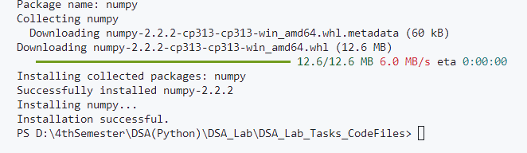

## Advanced Problems

### Question 11: Polymorphism: Shapes Area Calculation

Create a base class Shape with a method calculate_area().

Implement two child classes Rectangle and Circle with overridden methods to calculate the area of their respective shapes.

o Input: Rectangle: length=5, width=3; Circle: radius=4

o Output:

Rectangle Area: 15

Circle Area: 50.24

#### Code:

import math

class Shape:

    def calculate_area(self):

        pass

class Rectangle(Shape):

    def __init__(self, length, width):

        self.length = length

        self.width = width

    def calculate_area(self):

        return self.length * self.width

class Circle(Shape):

    def __init__(self, radius):

        self.radius = radius

    def calculate_area(self):

        return math.pi * self.radius ** 2

# Input

length = float(input("Enter length of rectangle: "))

width = float(input("Enter width of rectangle: "))

radius = float(input("Enter radius of circle: "))

rect = Rectangle(length, width)

circle = Circle(radius)

# Output

print("Rectangle Area:", rect.calculate_area())  # Output: 15

print("Circle Area:", round(circle.calculate_area(), 2))  # Output: 50.24

#### Output:

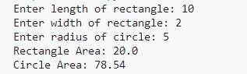

### Question 12: Abstract Class for Payment Processing

Create an abstract class Payment with an abstract method process_payment(). Implement subclasses CreditCardPayment and

PaypalPayment with their respective implementations.

o Input: Payment Type: Credit Card, Amount: 1000

o Output:

Processing Credit Card Payment of Rs. 1000

#### Code:

from abc import ABC, abstractmethod

**class Payment(ABC):**

    @abstractmethod

    def process_payment(self, amount):

        pass

class CreditCardPayment(Payment):

    def process_payment(self, amount):

        print(f"Processing Credit Card Payment of Rs. {amount}")

class PaypalPayment(Payment):

    def process_payment(self, amount):

        print(f"Processing PayPal Payment of Rs. {amount}")

**# Input**

payment_type = input("Enter payment type('Credit Card' or 'Pay Pal'): ")

amount = float(input("Enter amount: "))

if payment_type == "Credit Card":

    payment = CreditCardPayment()

elif payment_type == "PayPal":

    payment = PaypalPayment()

#### Output:



### Question 13: JSON Data Analysis

Write a program to load a JSON file containing student data (name, marks) and calculate the average marks of all students.

o Input JSON:

[

{"name": "Alice", "marks": 85},

{"name": "Bob", "marks": 90},

{"name": "Charlie", "marks": 78}

]

o Output: Average Marks: 84.33

#### Code:

import json

def calculate_average_marks(json_data):

    students = json.loads(json_data)

    total_marks = sum(student['marks'] for student in students)

    average_marks = total_marks / len(students)

    return round(average_marks, 2)

# Input JSON

json_data = '''

[

    {"name": "Alice", "marks": 85},

    {"name": "Bob", "marks": 90},

    {"name": "Charlie", "marks": 78}

]

'''

average_marks = calculate_average_marks(json_data)

print("Average Marks:", average_marks)

#### Output:



### Question 14: Regex Search in Log File

Write a program to extract all IP addresses from a given

server log file using regex.

o Input File Content:

192.168.1.1 - Accessed on 2025-01-19

10.0.0.2 - Accessed on 2025-01-20

o Output:

IP Addresses: 192.168.1.1, 10.0.0.2

#### Code:

import re

def extract_ip_addresses(file_content):

    pattern = r'\b(?:\d{1,3}**\.**){3}\d{1,3}\b'

    ip_addresses = re.findall(pattern, file_content)

    return ip_addresses

# Input File Content

log_content = '''

192.168.1.1 - Accessed on 2025-01-19

10.0.0.2 - Accessed on 2025-01-20

'''

ip_addresses = extract_ip_addresses(log_content)

print("IP Addresses:", ", ".join(ip_addresses))

#### Output:



### Question 15: File Handling: Merge and Sort Files

Write a program to merge two text files and sort the combined content alphabetically.

o Input File 1: "apple, banana, orange"

o Input File 2: "cherry, fig, grape"

o Output File: "apple, banana, cherry, fig, grape, orange"

#### Code:

def merge_and_sort_files(file1_path, file2_path, output_file_path):

    with open(file1_path, 'r') as file1, open(file2_path, 'r') as file2:

        content1 = file1.read().split(', ')

        content2 = file2.read().split(', ')

    merged_content = sorted(content1 + content2)

    with open(output_file_path, 'w') as output_file:

        output_file.write(', '.join(merged_content))

# Input Files Content

file1_path = 'file1.txt'

file2_path = 'file2.txt'

output_file_path = 'output.txt'

with open(file1_path, 'w') as file1:

    file1.write("apple, banana, orange")

with open(file2_path, 'w') as file2:

    file2.write("cherry, fig, grape")

# Process and Output

merge_and_sort_files(file1_path, file2_path, output_file_path)

with open(output_file_path, 'r') as output_file:

    print(output_file.read())  # Output: apple, banana, cherry, fig, grape, orange

**Files Created:**

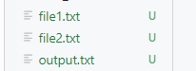

#### Output:

